If you need assistance with any portion of the 2024 VBR please do not hesitate to
ask for help! We are all willing to assist or lead you in the right direction.

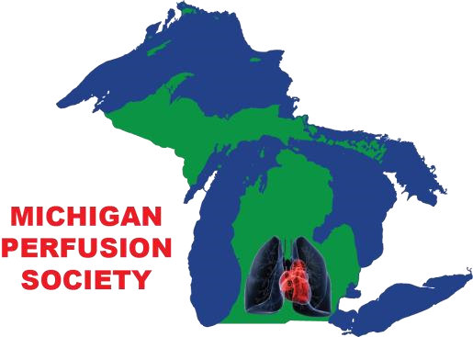
Contacts:
Michigan Perfusion Society
Tammy Atwood, MPS President – cell 734-476-8569 or atwoodt05@gmail.com
Brittney Graebner, Immediate Past President- cell 989-798-0243 or bgraebner@perfusionofmi.com
Jeff Chores, Past President- cell 586-215-8969 or jbchores@gmail.com

MSTCVS Collaborative:
Don Neiter, PERForm Quality Initiative Coordinator – cell 419-490-6466 or dnieter@med.umich.edu
Raquel Hazzard, Admin/Project Coordinator- rhazzard@med.umich.edu

PERForm Database Help:
Lara Blair, Health Catalyst, lara.blair@healthcatalyst.com

